Chapter 13 Work & Energy
Review Questions
Using Key Terms
- For each of the following, state whether the system contains primarily kinetic energy or potential energy:
- a stone in a stretched slingshot
- a speeding race car
- water above a hydroelectric dam
- List several examples that show how electrical energy and light energy are useful to you.
- Name three simple machines that make up a can opener, which is a compound machine.
UNDERSTANDING KEY IDEAS
- __________ is defined as force times distance.
  - Power b. energy c. work d. potential energy
- The quantity that measures how much a machine multiplies force is called
  - Mechanical energy b. leverage c. efficiency d. power
- The unit that represents 1 J of work done each second is the
  - Power b. Newton c. watt d. mechanical advantage
- Which of the following phrases describes a situation in which potential energy is not changed into kinetic energy?
  - an apple falling from a tree
  - a dart being shot from a spring-loaded gun
  - the string of a bow being pulled back
  - a creek flowing downstream
- _____ is determined by both mass and velocity.
  - Work b. power c. potential energy d. kinetic energy
- Type of energy that does not involve the large-scale motion or the position of objects in a system is called ______________ energy.
  - Potential b. mechanical c. non-mechanical d. conserved

- A machine cannot
  - change the direction of a force.
  - multiply or increase a force.
  - increase the total amount of work done.
  - redistribute work.
- A machine that has a mechanical advantage of less than one
  - increases speed and distance.
  - multiplies force.
  - increases output force.
  - reduces distance and speed.
- Which of these statements describes the law of conservation of energy?
  - No machine is 100% efficient.
  - Energy is neither created nor destroyed.
  - The energy resources of Earth are limited.
  - The energy of a system is always decreasing.
- What type of simple machine turns a downward force into two forces directed out to the sides?
  - Lever b. screw c. wedge d. pulley
- The mass of a penny is 2.5 g. If the penny is held out a window on one of the upper floors of the Empire State Building, 350 m off the ground, what is the gravitational potential energy of the penny with respect to the ground?
  - 0.875 J b. 8.575 J c. 140 J d. 875 J
- What type of potential energy is stored within food and used by the consumer of the food?
  - Elastic b. mechanical c. chemical d. gravitational
- A veterinarian picks up a small dog from the floor and places it on the operating table. If the dog weighs 80 N and the operating table is 1.25 m high, how much work does the veterinarian do?
  - 64 W b. 64 J c. 100 W d. 100 J

EXPLAINING KEY IDEAS
- If a machine cannot multiply the amount of work, what is the advantage of using a machine?

- You are trying to pry the lid off a paint can by using a screwdriver, but the lid will not budge. Should you try using a shorter screwdriver or a longer screwdriver? Explain.

- Many fuels come from fossilized plant and animal matter. How is energy stored in these fuels? How do you think that energy got into the fuels in the first place?

CRITICAL THINKING
- If a bumper car triples its speed, how much more work can it do on a bumper car at rest? (Hint: Use the equation for kinetic energy.)

- You are designing a roller coaster ride in which a car will be pulled to the top of a hill and then will be released to roll freely down the hill and up again toward the top of the next hill. The next hill is twice as high. Will your design be successful? Explain.

- In two or three sentences, explain the force-distance trade-off that occurs when a machine is used to make work easier. Use the lever as an example of one type of trade-off.

Graphing Skills
- The diagram below shows five points on a roller coaster.
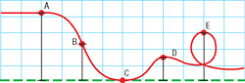
  - List the points (a, b, c, d, e) in order from the point where the car has the greatest potential energy to the point where the car has the least potential energy.

  - Now, list the points in order from the point where the car has the greatest kinetic energy to the point where the car has the least kinetic energy.

  - How do your two lists relate to each other?

Math Skills
- You and two friends apply a force of 425 N to push a piano up a 2.0 m long ramp.
  - How much work, in joules, has been done when you reach the top of the ramp?

  - If you make it to the top in 5.0 s, what is your power output in watts?

  - If lifting the piano straight up requires 1,700 N of force, what is the mechanical advantage of the ramp? (two friends apply a force of 425 N)

- A crane uses a block and tackle to lift a flagstone with a weight of 2,200 N to a height of 25 m.
  - How much work is done on the flagstone?

  - When the flagstone is 25 m above the ground, what is its potential energy?
(Hint: P.E. = weight x height)

- If a motorcycle with a mass of 250 kg has a kinetic energy of 200,000 J, what is the motorcycle’s speed in m/s? (v² = KE ÷ .5m)

- The pull of gravity (g) on Mars is 3.7 m/s². If an astronaut on Mars lifts a 10 kg rock 1 m off the ground, just to see what’s under it, how much work has the astronaut performed?

Reading Skills
PYRAMID POWER

One of the most ancient and amazing architectural creations in the world is the Great Pyramid of Egypt. This structure consists of several million rectangular blocks, each weighing an average of 2.5 tons.

The pyramid was assembled by using simple machines. Ramps made of wood, rock, and mud were most likely used to raise the blocks. Although the slope of a single ramp would be too steep to move such heavy objects, the workers may have used a series of smaller ramps.

Another possibility is that the gigantic blocks were moved by using a pulley connected to a counterweight set on a sloping ramp on the other side of the Pyramid. When the counterweight was set, it would be attached to a heavy block and released. The lowering of the counterweight would raise the massive block.

- What two simple machines may have been used to construct the Great Pyramid?
a. lever and pulley
b. lever and inclined plane
c. pulley and wedge
d. pulley and inclined plane

29. 100 workers pull a 3 ton block to 100 m high using a ramp with a mechanical advantage equal to 4. With each heave, each worker does 50 J of net work. How many heaves will it take for the workers to pull the block all the way up the ramp? (Note: 1 ton = 8,896 newtons.)
a. 14 heaves b. 134 heaves c. 1335 heaves d. 13,344 heaves

30. Why would a long series of gradual ramps be better than one short, steep ramp for moving heavy blocks of stone?

Interpreting Graphics
The following diagram shows the complete arc of one swing of a pendulum.
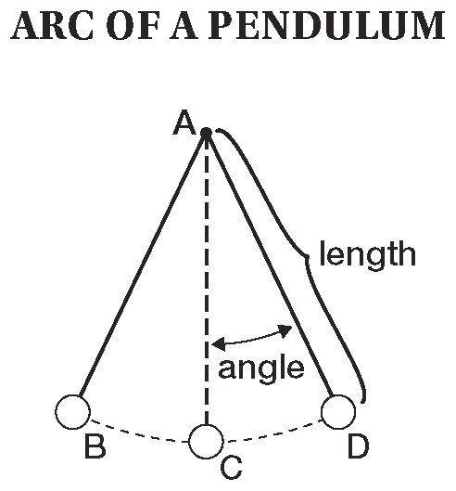
31. Where does the pendulum weight have the greatest gravitational potential energy?
- A b. A & C c. C d. B & D

32. Where does the pendulum weight have the greatest kinetic energy?
- A b. A & C c. C d. B & D

On a distant planet, an extraterrestrial fruit falls from a tree. We know the gravitational potential energy of the alien fruit at point A and its velocity at point B.

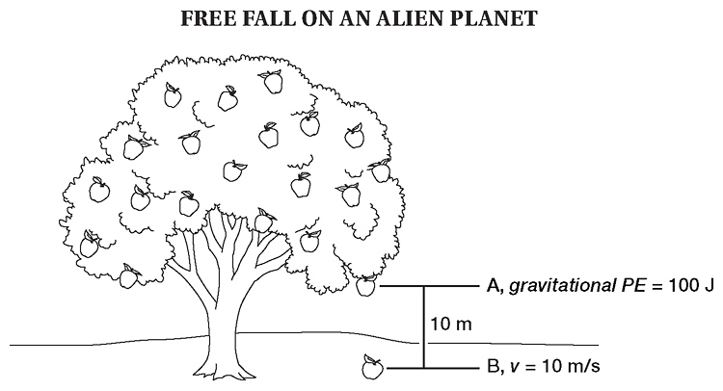

33. What is the mass of the alien fruit? Assume that GPE = KE; mgh = ½ mv²
a. 1 kg b. 2 kg c. 5 kg d. 10 kg

34. What is the free-fall acceleration (g) of the alien planet? g = GPE / m x h

W

