2.1.1 – 2.1.3 TEST Classification of Matter Name: _______________________ Date _______ Pd:_____
Choose the best answer for each of the following, answer on the Scantron - Use No. 2 pencil

2.1.1
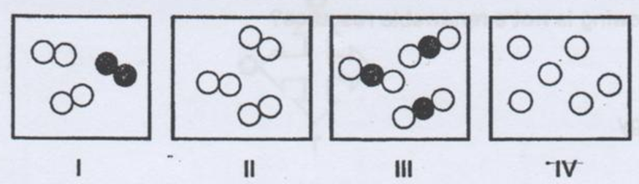
Answers may be used more than once or not at all.
- element only b. mixture of elements
- compound only d. mixture of compounds and elements

- I = ___________ 3) III = ___________
- II = ___________ 4) IV = ___________

5) In a solution the substance that is being dissolved is called the_____________
a. solvent b. solute
c. emulsifier d. filtrate

6. What is one property of a suspension that is different from that of a solution or a colloid?
a. If left to rest, the particles of a suspension will not settle out.
b. A suspension is always clear
c. Suspensions are colorless
d. If left to rest, the particles of a suspension will settle out.

7. A solution that cannot hold any more solute at room temperature is ___
a. A weak solution b. A concentrated solution
c. A saturated solution d. An unsaturated solution

8. An example of a solution is ___
a. Sugar and water b. Milk
x. Sand and water d. Whipped Cream

9. What makes water such a good solvent?
a. Water is a good solvent because it is a negatively charged ion.
b. Water is such a good solvent because it repels most molecules
c. Water is such a good solvent because it is such a small molecule
d. Water is a good solvent due to its polarity

10. The property of a colloid to scatter light is known as ________________________.
a. dispersion b. Tyndall Effect
c. dissolving d. Mercalli Scale

Identify the following as a (an)…..
- element b. homogeneous mixture of elements
- compound d. heterogeneous mixture

11. sugar water
12. salt
13. granite
14. sodium nitrate
15. neon gas
16. silver

2.1.2
Choose the letter or letters that correctly identify the following:
- definite composition c. retains its shape
- takes shape of the container d. is compressible

17. Solid _______________
18. Liquid _____________
19. Gas ______________
Use the following diagrams to identify the state of matter.
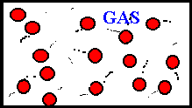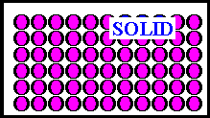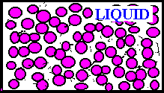
A B C
LIQUID
LIQUID
LIQUID

20. Solid ______________
21. Liquid ____________
22. Gas ______________
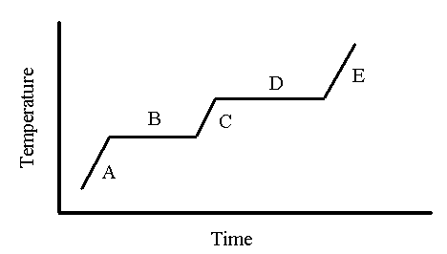
Choose the letter or letters that correctly identify the following:
23. Only one state of matter is present ___________________
24. Boiling point _________________________
25. Condensation point _____________________
26. Liquids are present in __________

27. Increasing thermal energy will increase the ________________ of the object and cause the atoms to ______________ .
a. potential energy, expand b. potential energy, contract
c. kinetic energy, expand d. kinetic energy, contract

2.1.3
Use the correct answer choice to identify the correct property or change.
Answers may be used more than once or not at all.

a. physical change b. chemical change c. physical property d. chemical property

28. mixing sand and salt
29. rusting an iron nail
30. density = 6.3 g/cm³
31. cooking an egg
32. flammable

33. ____Several common metals are listed in this chart. Assuming equal masses of each, a cube of which metal would have the greatest volume

Common Metals
Metal | Density (g/cm3 )
Aluminum | 2.7
Iron | 7.9
Silver | 10.5
Lead | 11.4

- aluminum b. iron c. silver d. lead

34. The chart below represents the melting and boiling points of several materials.
Which is a gas at 60○C?

Substance | Melting Point (○C) | Boiling Point (○C)
A | -119 | 79
B | -95 | 65
C | -82 | 37
D | -94 | 64

Use the Solubility Curve Chart to answer the following:

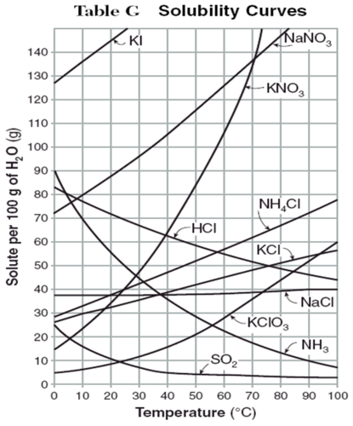
35. What mass of KNO³ solute will dissolve in 100mL of water at 70○C ?
- 103g b. 49g c. 132g d. cannot be determined

36. John has a solution that contains 50g of NH₄Cl at 50°C (in 100 mL H₂O). The solution would be classified as ________________.
a. supersaturated b. unsaturated c. saturated

37. Which substance has the least change of solubility from 0○C to 100○C ?
- NH ₃ b. KI c. NH₄Cl d. NaCl

38. Which substance is classified as a gas?
- NH ₃ b. KI c. NH₄Cl d. NaCl

39. Jorgia has a solution that contains 80g of NaNO₃ at 10°C (in 100 mL H₂O). If the solution is heated to 40°C , how much more solute could dissolve?
a. 45 g b 35g c. 25g d. no more solute could be dissolved

